**- INPUT DEVICES:**

1. Keyboard
2. Mouse
3. Joy Stick
4. Light pen
5. Track Ball: move fingers on the ball then the pointer can be moved.
6. Scanner
7. Digitizer( Graphics Tablet) converts analog information into digital form. Digitizer can convert a signal from the television or camera into a series of numbers that could be stored in a computer.:
8. Microphone
9. Magnetic Ink Card Reader(MICR): The bank's code number and cheque number are printed on the cheques with a special type of ink that contains particles of magnetic material that are machine readable.
10. Optical Character Reader(OCR) : OCR scans the text optically, character by character, converts them into a machine readable code, and stores the text on the system memory.
11. Bar Code Reader
12. Optical Mark Reader(OMR): recognize the type of mark made by pen or pencil

**- OUTPUT DEVICES:**

1. Monitors
2. Graphic Plotter
3. Printer 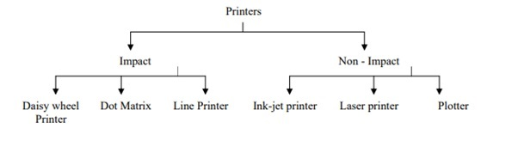
4. Speakers
5. Headphones
6. Projector
7. GPS